# General design concepts

## Metrics

**Strength**: measures if the solution has the physical strength of sending the charger to the desired position

**Ease of implement**: how easy is the solution for us to actually assemble/program.

**Ease of control/calibrate**: how easy is the solution for us to apply control to it, such as PID control or constant feedback control

**Cost**: Estimate of price, including shipping cost and the time for it to arrive

**Online resources**: if there are abundant community support and forums, youtube tutorials, online textbooks etc for us to figure out things we do not know

**Flexibility(including programming)**: how many different kinds of tasks is the solution capable of doing before specifying constraints

## Alternatives

**Moveable Base**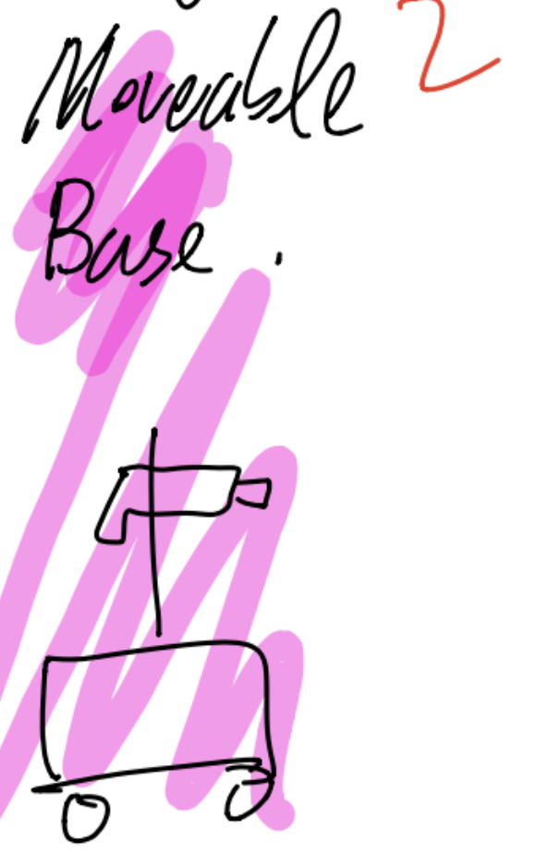

Pros:

* Provides sufficient power to insert the charger into the port
* Accounts for 3 degrees of freedom:x, y, angle

Cons:

* Probably hard to calibrate motors to work at a level of precision (need control)
* Might not be stable, wheels can be slippery
* Usually require a flight controller

**Robotic track**

Pros: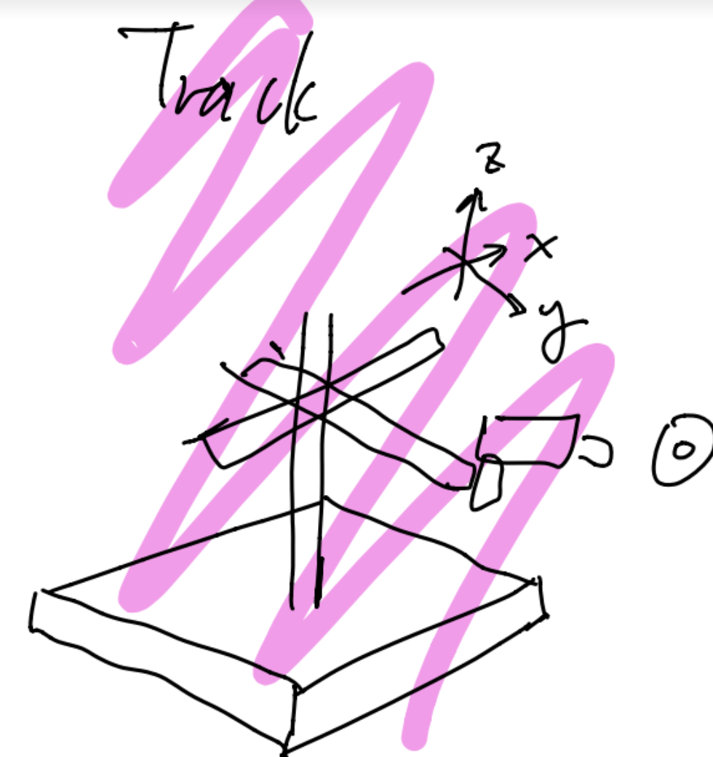

* Accounts for z-axis, relatively easy to implement
* Relatively easy to program and control

Cons:

* Not sure if it is strong enough to lift the charger
* Might not be strong enough to insert the charger
* Stability concerns
* Cannot use for angle

Community support: <https://www.robotshop.com/community/forum/t/robot-tracks/15478>

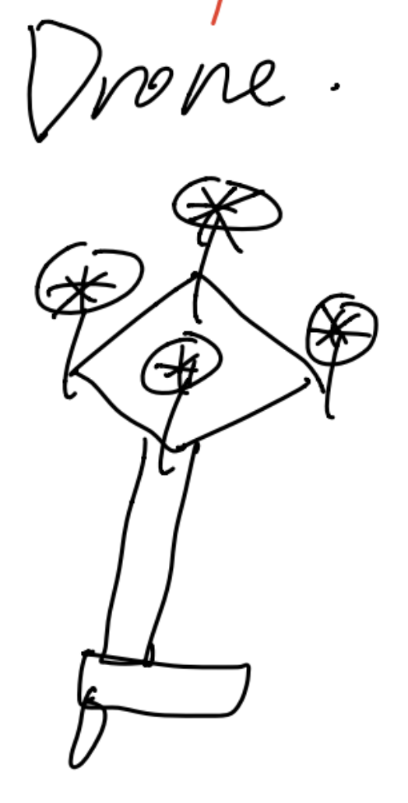

**Drone**

Pros:

* fancy

Cons:

* Extremely expensive (cheapest commercial sails start from 300, it would be hard to build one with a lower price)
* Extremely hard to program
* Hard to control
* Lack of strength to insert the charger

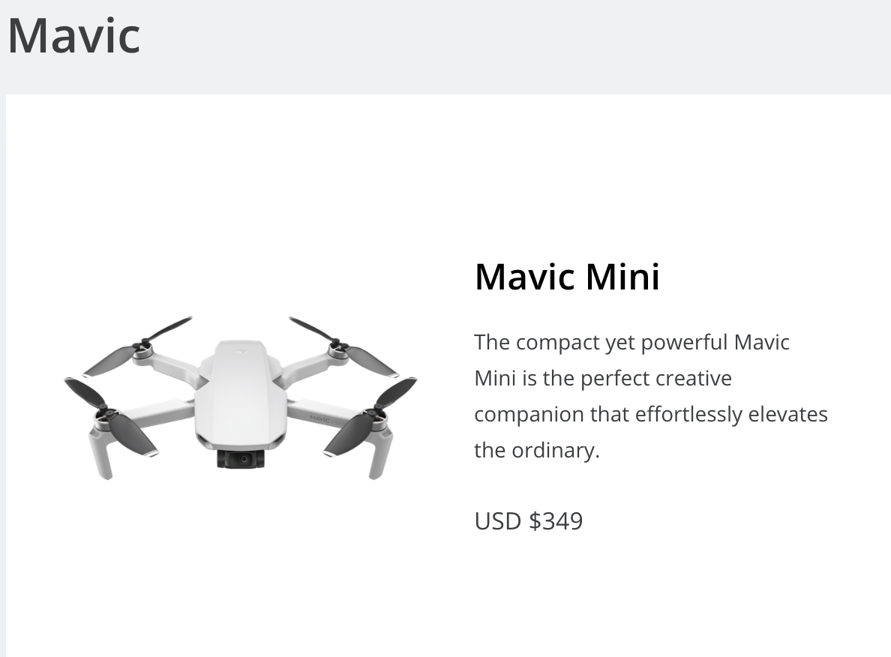 from:<https://store.dji.com/shop/mavic-series?from=menu_icon>

**Soft robotic arm**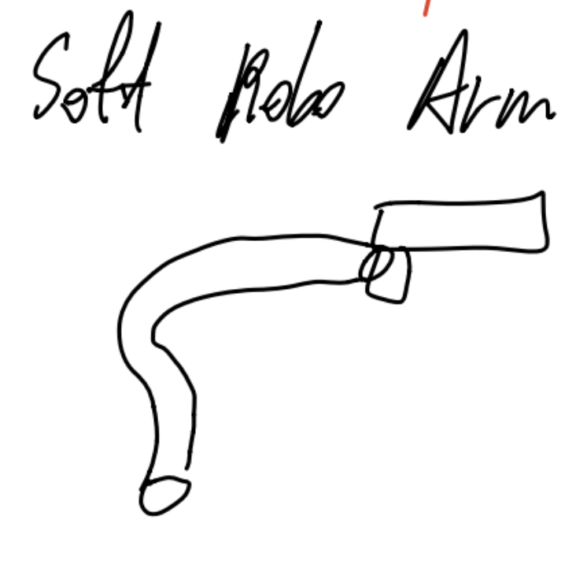

Pros:

* Fancy

Cons:

* Likely hard to calibrate and control
* Not sure about the strength
* Lack of online resources

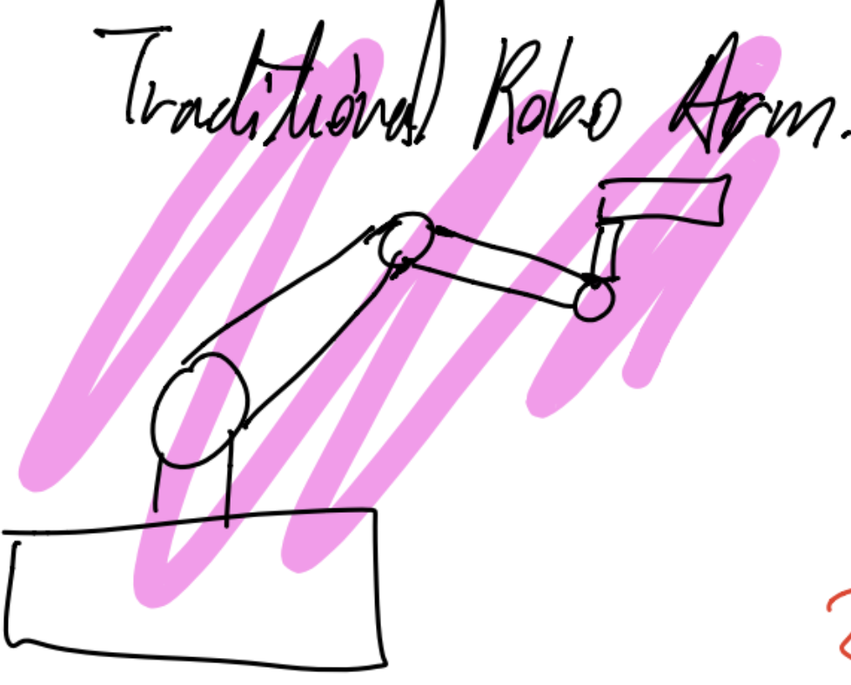

**Robotic arm**

Pros:

* Accounts for the degree of freedom of angle
* Many online resources

Cons:

* Strength purely depends on the servo motor strength at its connections
* Unsure about how to program

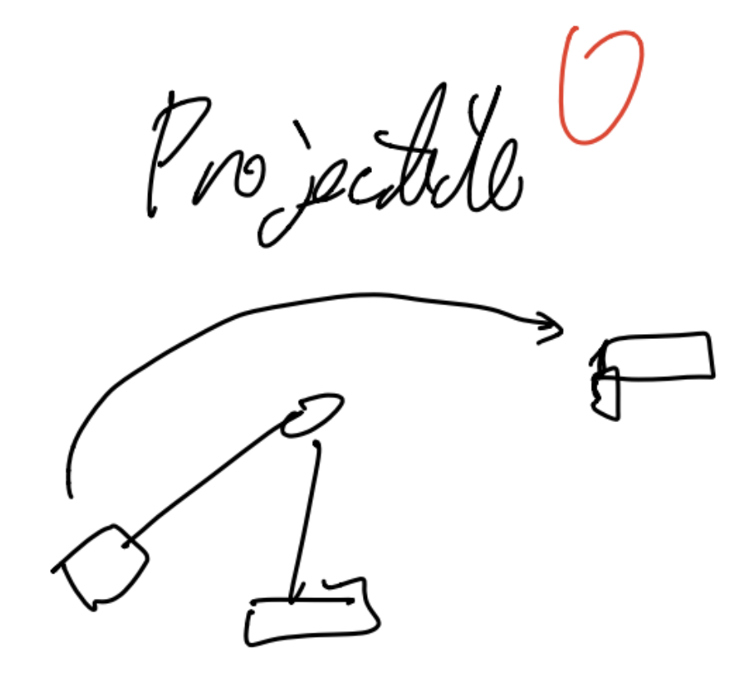

**Projectile**

Pros:

* Likely nobody will be doing it
* Fast, easy to build
* Low cost

Cons:

* Extremely difficult to control for accuracy
* Depends on luck
* Highly likely not able to get the task done